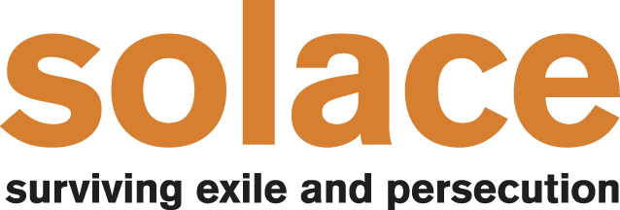

Strategic Plan 2019 – 2022

Our purpose:
“to alleviate the sickness, distress and suffering of refugees and asylum seekers in the Yorkshire and Humberside Region, in particular those suffering from mental health problems or emotional difficulties by providing a range of services including therapeutic interventions, crisis counselling, advocacy and opportunities for social support with the object of improving the life of said persons.”

Our key aims for the next three years:
- To provide a range of therapeutic services that genuinely meet the needs of refugees and asylum seekers

- To be a well run organisation

- To be able to tell our story and share our learning

- To be a good place to work and volunteer

Introduction:
Solace was created in 2006 to meet the need for therapeutic support for traumatised refugees who were being dispersed to the Yorkshire and Humber region. Mental health services, nationally and locally have always been very stretched, and trying to meet the needs of this particular group of people was, and still is very challenging. Since 2007 Solace has developed wide ranging expertise on how best to improve the wellbeing and mental health of refugees and asylum seekers and we are acknowledged as the leading specialist provider of therapeutic services for refugees regionally.
This strategic plan has been developed as a result of conversations and structured consultations with our team of staff and volunteers, and with external stakeholders who recognise the importance of what we do.
We acknowledge that funding streams come and go, so rather than focus on practicalities such as where and how much service we will deliver this plan highlights the key aspects of Solace that we want to see flourish. We believe that our services and support are invaluable, and that we make a huge difference to the people we support. We will do all we can to make our support increasingly available to refugees and asylum seekers, but recognise that reaching more people must not come as a result of watering down the quality of our service. Demand for our support is growing across the region, and it is vital that however big or small our services are they are based on our key aims, meet our objectives and most of all are guided by our ethos and values.

Our values:
- Striving for professional excellence and a commitment to finding out what is most helpful therapeutically for refugees and asylum seekers.

- Compassion and kindness

- Keeping the clients at the heart of everything we do
Our underpinning ethos: what is it that defines Solace and guides the principles of service development?
It is inevitable that services will need to be delivered differently across the region and our strength lies in our flexibility to draw on the wide ranging expertise we have developed and our commitment to integrative practice rather than having just one way of doing things.
There are however some things that define what we do, and are essential to any service we deliver.
All Solace services:
- Will recognise that we don’t deliver therapy in a vacuum. We will “see the whole person” and not just their mental health needs. We will acknowledge the context in which they are living and we will help them to navigate the asylum system and other complex and confusing systems essential to living in the UK.

- Will help clients identify their strengths and do more for themselves. We will strive to be well linked in with other services locally so we can help clients access and make use of the resources available to them.

- Will give information and take the time to explain things to our clients, and to other organisations when there is confusion. We see it as part of our role to help clients articulate their needs and to support them to have their voice heard.

- Won’t turn clients away because they are “not ready” for therapy. We will meet people where they are, and support people who have ongoing trauma and fear. We can’t meet all the needs of our clients, but we will always look for the things we can do.

- Will focus on refugees and asylum seekers. We aim to maintain our specialism because we know that this group of people have particular needs. We want to continue to develop expertise in supporting people who have fled from their home because of violence and persecution.

Our key aims:
We identified four aims for our development over the next three years. Our operational plan will expand on these aims and provide the means to monitor our progress throughout the year.

- Provision of a range of therapeutic services that genuinely meet the needs of refugees and asylum seekers
- A range of therapies available to meet needs
- Going out of our way to provide support eg letters and referrals
- Focus on quality improvement.
.
- Being a well run organisation
- Financially solvent
- Legally compliant
- Meeting our contract and funder requirements
- Have sufficient resources (people and expertise) to deliver services well.

- Being able to tell our story and share our learning.
- So we can help improve services more widely for refugees and asylum seekers.
- So we can actively demonstrate our expertise and be seen as the leading provider in this area.

- Being a good place to work and volunteer
- Supporting each other
- Providing development and learning
- Trying new things and taking some risks in being able to get things wrong and learn from it
- Being transparent in decision making and treating people fairly

